**Quick Post Web**

**A Modern Blogging Platform**

Submitted By:

Name = **Tushar Saini**

Roll No = **2301301463**

**B. Tech CSE Section-4, 3nd Year**

To

**Mrs. Neetu Mourya**

**Academic Year**

**2025-26**



**Department of Computer Science & Engineering**

**Quantum University, Roorkee**

**CERTIFICATE**

This is to certify that the project report entitled **“Quick Post – A Modern Web-Based Blogging Platform”** is submitted by **Mr. Tushar Saini** in partial fulfilment for the award of the degree of **Bachelor of Technology in Computer Science and Engineering**, and it is a record of bonafide work carried out by him during his **Summer Internship / Project Course** under my guidance and supervision in the Department of **Computer Science and Engineering**; the work presented in this report has not been submitted earlier to any university or institution for the award of any degree or diploma.

(Name & Signature) (Name & Signature)

Project Guide Program Officer, CSE

(Name & Signature)

HoD, CSE & Dean Academics, QU

**DECLARATION**

I hereby declare that the project entitled **“Quick Post Web – A Modern Blogging Platform”**, submitted for the award of the **B.Tech degree in Computer Science and Engineering**, is my original work and has not formed the basis for the award of any degree, diploma, or any other similar title in any college, institute, or university; I further declare that this work was carried out as part of a **Course-Based Online Internship through the Udemy platform**, where technical skills were acquired through structured learning modules, hands-on coding exercises, and comprehensive assessments, and subsequently applied to the development of this final project, representing my own understanding and implementation of the subject matter.

**Name:** Tushar Saini

**Degree:** B.Tech (CSE)

**University:** Quantum University, Roorkee

**Date:** 15th December 2025

**Signature:** _________________

**ACKNOWLEDGEMENTS**

I would like to express my sincere gratitude to the Department of Computer Science and Engineering, Quantum University, Roorkee, for providing the academic infrastructure, learning resources, and institutional support necessary to successfully complete this internship-based project. The department’s structured curriculum, emphasis on practical exposure, and academically enriching environment played a crucial role in strengthening my technical foundation and overall professional development.

I am deeply thankful to my internal guide and supervisor for their invaluable guidance, constant encouragement, and constructive feedback throughout the development of the *Quick Post Web* project. Their technical insights and thoughtful suggestions were instrumental in improving the system architecture, optimizing implementation strategies, and ensuring that the project met the quality standards required for academic submission.

I also extend my sincere appreciation to the Udemy platform and its instructors for offering a well-structured course-based online internship in Web Development. The comprehensive video lectures, hands-on coding exercises, and industry-aligned assignments provided the technical knowledge and practical skills required to design and develop a modern web-based application. The self-paced learning approach enabled in-depth exploration of key concepts such as state management, frontend-backend integration, and scalable application development.

Finally, I express my heartfelt thanks to my parents and friends for their unwavering support, encouragement, and patience throughout the long hours of coding, testing, and debugging involved in completing this project. Their motivation and understanding were a constant source of strength and played an important role in bringing this project to a successful conclusion.

Tushar Saini

B.Tech (CSE)

**TABLE OF CONTENT**

|  |  |  |
| --- | --- | --- |
| Certificate of the Supervisor | | i |
| Declaration | | ii |
| Acknowledgements | | iii |
| Table of Contents | | iv-vi |
| List of tables | | vii |
| List of figures | | viii |
| List of abbreviations | | ix |
| Abstract | | x |
| Course Certificate | | xi |
| **CHAPTER 1:** | **INTRODUCTION** | 1-3 |
| 1.1 | Overview of Web Development | 1 |
| 1.2 | Evolution of Blogging Platforms | 1 |
| 1.3 | Importance of Modern Web Applications | 2 |
| 1.4 | Objectives of the Internship and Project | 3 |
| **CHAPTER 2:** | **INTERNSHIP ORGANIZATION & COURSE PLATFORM** | 4-5 |
| 2.1 | Overview of Udemy | 4 |
| 2.2 | Course-Based Internship Model | 4 |
| 2.3 | Learning Methodology and Assessment Process | 4 |
| 2.4 | Benefits of Online Industry-Oriented Training | 5 |
| **CHAPTER 3:** | **PROJECT OVERVIEW** | 6-9 |
| 3.1 | Problem Statement | 6 |
| 3.2 | Purpose of Quick Post Web | 6 |
| 3.3 | Target Users | 7 |
| 3.4 | Key Features and Scope | 7 |
| 3.5 | Comparison with Existing Blogging Platforms | 8-9 |
| **CHAPTER 4:** | **SYSTEM ARCHITECTURE & DESIGN** | 10-12 |
| 4.1 | Overall System Architecture | 10 |
| 4.2 | Frontend Architecture | 10 |
| 4.3 | Backend Services | 11 |
| 4.4 | Database Design | 11 |
| 4.5 | ER Diagram and Data Flow Diagram | 12 |
| **CHAPTER 5:** | **TECHNOLOGIES & TOOLS USED** | 13-15 |
| 5.1 | React.js | 13 |
| 5.2 | Redux Toolkit | 13 |
| 5.3 | React Hook Form | 14 |
| 5.4 | TinyMCE Editor | 14 |
| 5.5 | Appwrite (Backend as a Service) | 14 |
| 5.6 | HTML, CSS, JavaScript | 14 |
| 5.7 | Version Control (Git) | 15 |
| **CHAPTER 6:** | **FUNCTIONAL MODULES OF QUICK POST WEB** | 16-19 |
| 6.1 | User Authentication & Authorization | 16 |
| 6.2 | Post Creation and Editing | 16 |
| 6.3 | Rich Text Editor Integration | 17 |
| 6.4 | State Management | 17 |
| 6.5 | Blog Listing, Viewing, and Deletion | 18 |
| 6.6 | Responsive UI Design | 18-19 |
| **CHAPTER 7:** | **IMPLEMENTATION DETAILS** | 20-26 |
| 7.1 | Folder Structure | 20-23 |
| 7.2 | Component-Based Design | 23 |
| 7.3 | API Integration | 23 |
| 7.4 | Database Collections | 24 |
| 7.5 | Code Snippets with Explanation | 25-26 |
| **CHAPTER 8:** | **USER INTERFACE & USER EXPERIENCE** | 27-30 |
| 8.1 | Design Principles Used | 27 |
| 8.2 | Layout and Navigation | 27 |
| 8.3 | Accessibility Considerations | 28 |
| 8.4 | Screenshots Explanation | 28-30 |
| **CHAPTER 9:** | **TESTING & VALIDATION** | 31-32 |
| 9.1 | Functional Testing | 31 |
| 9.2 | User Input Validation | 31 |
| 9.3 | Performance Testing | 31 |
| 9.4 | Error Handling | 32 |
| **CHAPTER 10:** | **CHALLENGES FACED & SOLUTIONS** | 33 |
| 10.1 | Technical Challenges | 33 |
| 10.2 | Learning Curve | 33 |
| 10.3 | Debugging and Optimization | 33 |
| 10.4 | Solutions and Best Practices Adopted | 33 |
| **CHAPTER 11:** | **LEARNING OUTCOMES** | 34 |
| **CHAPTER 12:** | **FUTURE ENHANCEMENTS** | 35 |
| **CHAPTER 13:** | **CONCLUSION** | 36 |
| **REFERENCES / BIBLIOGRAPHY** | | 37 |

**LIST OF TABLES**

|  |  |  |
| --- | --- | --- |
| **Table No.** | **Title** | **Page No.** |
| 3.1 | Comparative Analysis of Blogging Architectures |  |
| 4.1 | Database Schema Definition – 'Users' Collection |  |
| 4.2 | Database Schema Definition – 'Posts' Collection |  |
| 5.1 | Technical Comparison of State Management Libraries |  |
| 6.1 | Functional Requirements Traceability Matrix |  |
| 9.1 | Test Case Specification – User Authentication Module |  |
| 9.2 | Test Case Specification – Post CRUD Operations |  |
| 9.3 | Cross-Browser Compatibility Testing Results |  |

**LIST OF FIGURES**

|  |  |  |
| --- | --- | --- |
| **Figure No.** | **Title** | **Page No.** |
| 1.1 | Timeline of Web Development Evolution |  |
| 3.1 | Use Case Diagram for Quick Post Web |  |
| 4.1 | High-Level System Architecture Diagram |  |
| 4.2 | Data Flow Diagram (DFD) Level 0 |  |
| 4.3 | Data Flow Diagram (DFD) Level 1 |  |
| 4.4 | Entity Relationship (ER) Diagram |  |
| 6.1 | Flowchart of User Authentication Process |  |
| 7.1 | React Component Hierarchy Tree |  |
| 8.1 | UI Screenshot – Welcome Page |  |
| 8.2 | UI Screenshot – User Login Interface |  |
| 8.3 | UI Screenshot – Home Feed and Dashboard |  |
| 8.4 | UI Screenshot – Rich Text Editor Interface |  |
| 8.5 | UI Screenshot – Mobile Responsiveness |  |

**LIST OF ABBREVIATIONS**

* **API:** Application Programming Interface
* **BaaS:** Backend as a Service
* **CMS:** Content Management System
* **CRUD:** Create, Read, Update, Delete
* **CSE:** Computer Science and Engineering
* **CSS:** Cascading Style Sheets
* **DOM:** Document Object Model
* **ES6:** ECMAScript 2015
* **HTML:** HyperText Markup Language
* **HTTP:** HyperText Transfer Protocol
* **JSON:** JavaScript Object Notation
* **JWT:** JSON Web Token
* **MERN:** MongoDB, Express.js, React.js, Node.js
* **MVC:** Model View Controller
* **NPM:** Node Package Manager
* **REST:** Representational State Transfer
* **RTE:** Rich Text Editor
* **SPA:** Single Page Application
* **UI/UX:** User Interface / User Experience
* **URL:** Uniform Resource Locator

**ABSTRACT**

The rapid evolution of the World Wide Web from a repository of static documents to a dynamic ecosystem of interactive applications has fundamentally changed how content is consumed and created. In this context, the development of robust Content Management Systems (CMS) and blogging platforms remains a cornerstone of the modern internet. This report documents the development of Quick Post Web, a modern, full-stack blogging application, developed during a Course-Based Online Internship on the Udemy platform.

The primary objective of this internship was to bridge the gap between academic theory and industrial application by mastering the React.js ecosystem. Unlike traditional internships, this course-based model provided a structured pedagogical approach, moving from fundamental JavaScript concepts to advanced state management and backend integration. The internship program emphasized self-paced learning, rigorous skill evaluation through mini-projects, and practical exposure to industry-standard tools like Git and Redux.

Quick Post Web is designed as a highly responsive Single Page Application (SPA) that allows users to create, read, update, and delete (CRUD) blog posts. The application leverages React.js for a dynamic frontend, Redux Toolkit for centralized state management, and Appwrite, a Backend-as-a-Service (BaaS) solution, to handle authentication, database management, and file storage. Key features include a rich-text editor (TinyMCE) for content creation, secure user authentication, and a responsive interface ensuring compatibility across devices.

This report details the entire software development lifecycle (SDLC) of the project, including the system architecture, technology stack selection, component design, implementation challenges, and testing methodologies. It provides an exhaustive analysis of the transition from monolithic architectures to headless solutions and demonstrates a nuanced understanding of client-side routing and state persistence. The successful completion of Quick Post Web demonstrates a comprehensive understanding of modern web development standards, component-based architecture, and cloud-native backend integration.

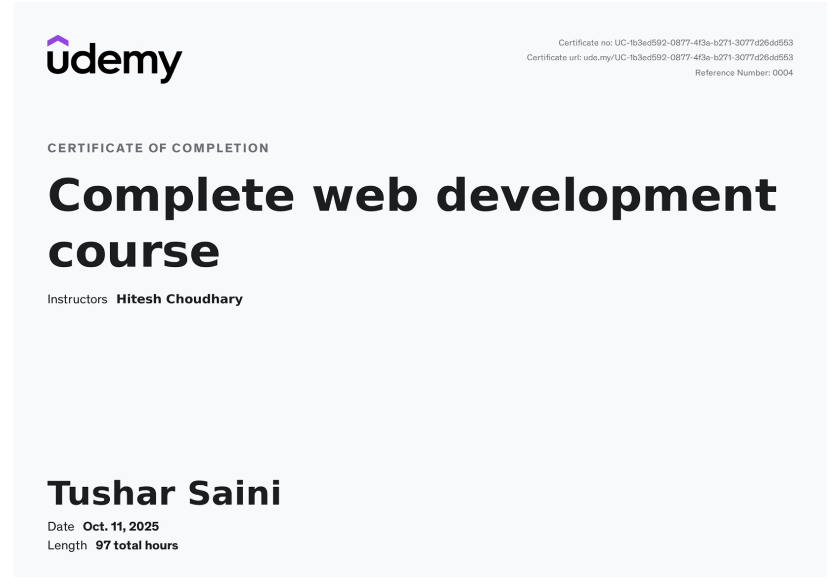**COURSE CERTIFICATE**

**CHAPTER 1: INTRODUCTION**

1. **Overview of Web Development**

The domain of Web Development has undergone a seismic shift over the last two decades, evolving from simple document serving to complex application delivery. This evolution is often categorized into three distinct phases: Web 1.0, Web 2.0, and the emerging Web 3.0.

**Web 1.0 (The Static Web):** In the early days of the internet, web development was primarily concerned with the creation of static HTML pages. Content was served exactly as it was stored on the server file system. Interactivity was virtually non-existent, and the role of the user was strictly that of a consumer. Technologies were limited to HTML, basic CSS, and minimal server-side scripting (CGI/Perl).

**Web 2.0 (The Social/Dynamic Web):** The paradigm shifted with the introduction of technologies like AJAX (Asynchronous JavaScript and XML) in the mid-2000s. This allowed web pages to update asynchronously by exchanging data with a web server behind the scenes, without interfering with the display and behavior of the existing page. This era gave birth to social media, blogging, and user-generated content. The distinction between "content consumer" and "content creator" blurred. Server-side languages like PHP (powering WordPress) and frameworks like Ruby on Rails became dominant.

**The Modern Era (SPA & The Component Revolution):** Today, we operate in an era often described as the age of the Single Page Application (SPA). Modern web development focuses on creating rich, application-like experiences within the browser. The distinction between a website and a native desktop application has blurred effectively. Technologies such as React.js, Vue.js, and Angular have empowered developers to build complex, state-driven interfaces that react instantly to user inputs without requiring full page reloads.

In this contemporary landscape, the role of a Full Stack Developer has expanded. It now encompasses not only the visual elements (Frontend) but also the logic, database management, and server configuration (Backend). However, the rise of Backend-as-a-Service (BaaS) platforms like Appwrite and Firebase has streamlined this process, allowing developers to focus intensely on the frontend experience while offloading complex infrastructure management to cloud services.

1. **Evolution of Blogging Platforms**

Blogging began in the late 1990s as "weblogs," digital diaries where individuals shared their thoughts. Early platforms like Open Diary and LiveJournal popularized the concept. The launch of WordPress in 2003 democratized publishing, powering over 40% of the web today. However, traditional CMS platforms like WordPress, while powerful, often suffer from "bloat"—carrying legacy code and excessive features that can slow down performance.

This limitation led to the rise of "Headless CMS" and custom-built blogging platforms. In a headless architecture, the content management (backend) is decoupled from the content presentation (frontend). This allows developers to build high-performance frontends using modern frameworks like React, retrieving content via APIs. **Quick Post Web**, the project detailed in this report, follows this modern paradigm. It is a custom-built blogging platform that offers the core functionalities of a CMS but is engineered with the lightweight, high-performance architecture of a React application.

1. **Importance of Modern Web Applications**

Modern web applications drive the global digital economy. For businesses and individuals, the ability to share content instantly and securely is paramount. The shift towards SPAs and modern frameworks is driven by several critical factors:

* **Performance:** Users expect instant load times. Modern SPAs load a single HTML page and dynamically update content as the user interacts with the app, significantly reducing bandwidth usage and perceived latency.
* **Scalability:** Component-based architectures allow applications to grow efficiently. A button component created once can be reused across the entire application, ensuring consistency and reducing code redundancy. This modularity is essential for large-scale engineering teams.
* **Cross-Platform Compatibility:** A well-designed web application functions seamlessly across desktops, tablets, and mobile phones, eliminating the need to develop separate native apps for different operating systems. This "write once, run everywhere" capability drastically reduces development costs.
* 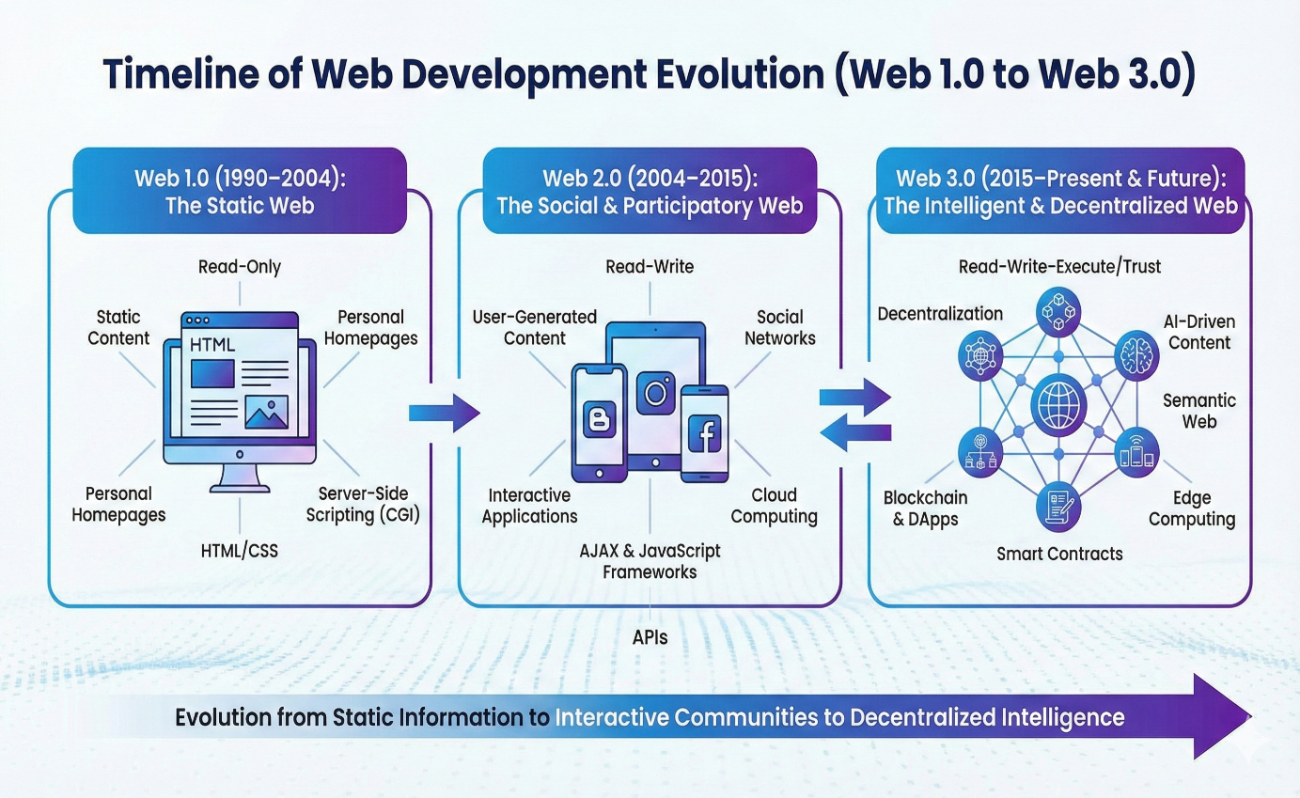**Developer Experience (DX):** Modern tools like React and Redux provide robust debugging capabilities (e.g., time-travel debugging), strict typing (via TypeScript or PropTypes), and a vast ecosystem of open-source libraries, accelerating the development lifecycle.

Figure 1.1 Timeline of Web Development Evolution

1. **Objectives of the Internship and Project**

The primary goal of this internship was to acquire industry-standard proficiency in web development through a rigorous, course-based learning path on Udemy. The specific objectives were multifarious:

1. **Technical Mastery:** To gain a deep, semantic understanding of JavaScript (ES6+), React.js, and Redux Toolkit. This involved moving beyond syntax to understanding the underlying execution context, event loop, and reconciliation algorithms.
2. **Architectural Understanding:** To learn how to structure a scalable web application, separating concerns between UI components, state management, and side effects (API calls). The objective was to implement a clean architecture that allows for easy maintenance and testing.
3. **Backend Integration:** To understand how to interface a frontend application with a cloud-native backend (Appwrite) to handle databases and authentication. This required understanding RESTful API principles, HTTP methods, and asynchronous data handling.
4. **Project Implementation:** To synthesize the learned concepts into a tangible product—**Quick Post Web**—that solves a real-world problem (content sharing) with a modern user interface.

**Professional Development:** To adopt professional coding standards, version control (Git), and debugging techniques used in the software industry. This included writing clean, self-documenting code and managing project dependencies via NPM.

**CHAPTER 2: INTERNSHIP ORGANIZATION & COURSE PLATFORM**

1. **Overview of Udemy**

Udemy is a leading global marketplace for learning and instruction. Unlike traditional academic institutions, Udemy connects expert instructors directly with learners, offering courses that are often more current with industry trends than standard university curricula. For technical fields like Computer Science, where tools and frameworks evolve annually, platforms like Udemy provide a critical bridge to the "cutting edge." The platform hosts over 150,000 courses and serves millions of students worldwide, democratizing access to high-quality technical education.

The specific course undertaken for this internship was **"Mega Project: Build a Modern Web App with React & Appwrite."** This course was rigorously selected for its comprehensive coverage of the entire development stack, moving beyond simple tutorials to complex, production-grade application logic.

1. **Course-Based Internship Model**

This internship was conducted in a **Course-Based Mode**. This model is increasingly recognized by academic institutions as a valid form of industrial training, particularly when the course involves significant hands-on project work and aligns with specific learning outcomes.1

**Structure of the Internship:**

* **Duration:** 8 Weeks (Self-Paced, equivalent to standard industrial hours).
* **Platform:** Online (Udemy).
* **Modules:**
* **Module 1:** JavaScript Refresher (Async/Await, Promises, DOM).
* **Module 2:** React Fundamentals (JSX, Props, State, Hooks).
* **Module 3:** Advanced React (Context API, Custom Hooks).
* **Module 4:** State Management (Redux Toolkit).
* **Module 5:** Backend Integration (Appwrite Setup, Database configuration).
* **Module 6:** The Capstone Project (Quick Post Web).

1. **Learning Methodology and Assessment Process**

The learning methodology followed a strict **"Watch-Code-Review"** cycle, ensuring active engagement rather than passive consumption:

1. **Theoretical Concept:** The instructor introduces a concept (e.g., React Context) and explains the underlying theory, often visualizing the data flow.
2. **Code-Along:** The student writes code alongside the instructor to implement the concept in isolation. This reinforces syntax and muscle memory.
3. **Assignment/Challenge:** The student is given a problem statement to solve independently using the learned concept. This phase is critical for developing problem-solving skills.
4. **Integration:** The concept is integrated into the main project (Quick Post Web). The student must figure out how the new feature interacts with existing code.

Assessment:

Progress was tracked through the completion of video modules and the successful execution of coding exercises. The final assessment was the operational status of the Quick Post Web application. If the application failed to compile, lacked features, or contained critical bugs, the internship objectives were considered unmet. This binary success/fail metric mimics real-world software delivery expectations where broken code cannot be deployed to production.

1. **Benefits of Online Industry-Oriented Training**

The course-based internship offers several distinct advantages over traditional shadowing internships, particularly in the context of software engineering:

* **Structured Curriculum:** Unlike some industrial internships where interns may be given menial tasks or lack mentorship, this course provided a structured path from zero to deployment. Every hour spent was focused on skill acquisition.
* **Technology Access:** It provided access to the latest stack (React 18, Redux Toolkit) which might not be available in legacy software companies. Many established firms still use older technologies (e.g., jQuery or AngularJS), limiting the intern's exposure to modern standards.
* **Code Quality:** The instruction emphasized "Clean Code" principles, teaching not just how to make things work, but how to write maintainable, readable code. Concepts like DRY (Don't Repeat Yourself) and SOLID principles were implicitly taught through component design.

**Debugging Skills:** Working independently required the student to debug errors without immediate senior intervention, fostering self-reliance and deep troubleshooting skills. This ability to read stack traces and search documentation is the hallmark of a competent engineer.

**CHAPTER 3: PROJECT OVERVIEW – QUICK POST WEB**

1. **Problem Statement**

In the contemporary digital ecosystem, content creation and dissemination have become fundamental forms of communication for individuals, organizations, and businesses. Blogging platforms play a crucial role in enabling users to publish articles, share opinions, and distribute knowledge. However, existing content publishing solutions exhibit a significant structural imbalance that limits their accessibility and usability for a wide range of users.

On one end of the spectrum, **lightweight platforms such as social media applications** offer ease of use but impose strict limitations. These platforms restrict formatting options, enforce character limits, and provide minimal control over content presentation. Moreover, content ownership is often compromised, as visibility is governed by proprietary algorithms and platform policies. Sudden changes in algorithms or service discontinuation can result in loss of reach or even permanent data loss for users.

On the other end, **traditional Content Management Systems (CMS) such as WordPress and Drupal** provide extensive functionality and customization capabilities. However, these platforms are often resource-intensive and complex to configure. Setting up such systems typically requires server provisioning, database configuration, plugin management, and ongoing maintenance. For individual developers, students, or small businesses, deploying a complete **LAMP (Linux, Apache, MySQL, PHP)** stack introduces unnecessary operational overhead, increased cost, and steep learning curves.

As a result, a large segment of users—particularly developers and small teams—remains underserved. There is a clear need for a **“middle-ground” blogging solution** that combines the simplicity of modern web applications with the flexibility and ownership offered by traditional CMS platforms. Such a system should be lightweight, fast, scalable, and customizable, while eliminating the complexity associated with monolithic architectures.

1. **Purpose of Quick Post Web**

Quick Post Web is designed to address the limitations of existing blogging solutions by adopting a **headless architecture** that decouples the frontend from backend services. The application leverages modern technologies—**React.js** for the frontend and **Appwrite** as a Backend-as-a-Service (BaaS)—to create a seamless, efficient, and scalable blogging platform.

The purpose of Quick Post Web can be defined from two distinct perspectives:

**1. User Perspective**

From the user’s standpoint, the platform aims to deliver a **fast, intuitive, and distraction-free writing experience**. The application is optimized for instant loading and smooth navigation, ensuring high performance across all devices. Writers can focus solely on content creation without being distracted by unnecessary technical configurations. Rich text editing, image support, and responsive layouts enhance readability and usability.

**2. Developer (Student) Perspective**

From a developer’s perspective, Quick Post Web serves as a **comprehensive portfolio-level project** that demonstrates proficiency in modern web development practices. It showcases the implementation of authentication workflows, cloud database interactions, file storage management, and advanced state handling in a single-page application. Additionally, the project highlights how modern web technologies can effectively replace traditional desktop-based or server-heavy content management solutions.

1. **Target Users**

Quick Post Web is intended for a diverse group of users, each benefiting from its modular and lightweight design:

* **Bloggers and Writers:**  
  Individuals seeking a minimalist platform that allows them to publish articles without dealing with server management, plugins, or complex configurations.
* **Developers:**  
  Programmers looking for a customizable and extensible blogging framework. The modular React-based architecture allows developers to adapt the system for personal projects or client-based applications.
* **Organizations and Startups:**  
  Small teams or startups requiring an internal content-sharing solution such as an announcement board, changelog, or knowledge base that can seamlessly integrate with existing React-based internal tools.

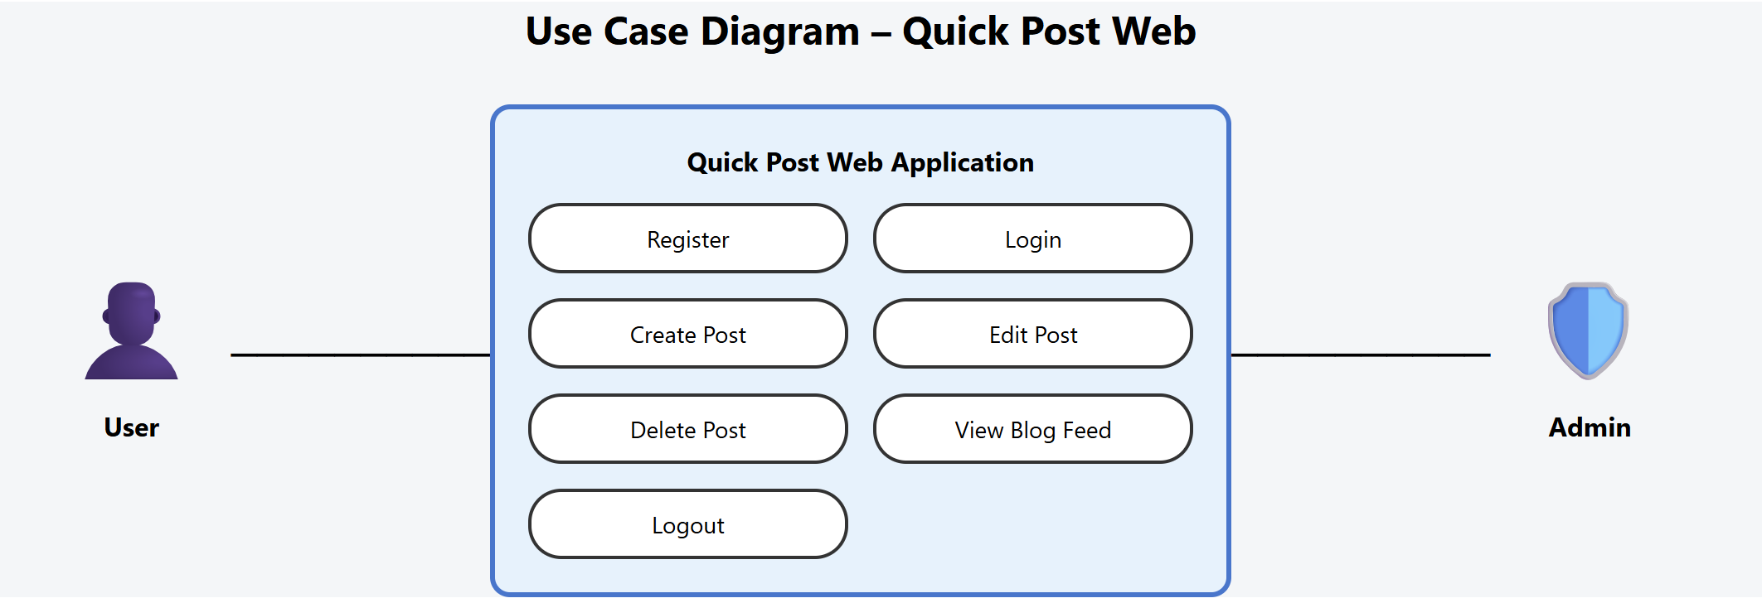Figure 3.1 Use Case Diagram for Quick Post Web

1. **Key Features and Scope**

The scope of Quick Post Web encompasses essential blogging functionalities, identified during the requirement analysis phase. These features ensure usability, security, and scalability:

**1. User Authentication**

* **Sign Up:** Secure user registration with email-based validation.
* **Login:** Authentication using JSON Web Tokens (JWT) managed by Appwrite.
* **Session Persistence:** Automatic session handling ensures users remain logged in across browser refreshes and sessions.

**2. Post Management (CRUD Operations)**

* **Create:** Users can compose posts with custom titles, URL-friendly slugs, and feature images.
* **Read:** Published posts are accessible to all users, including guests, and displayed in a responsive grid layout.
* **Update:** Authors can modify their existing posts, including content and images.
* **Delete:** Authors can permanently remove posts from both the database and associated cloud storage.

**3. Rich Text Editor**

The integration of **TinyMCE** provides advanced text formatting capabilities such as headings, lists, links, and inline styling. This feature bridges the gap between plain text editors and full-fledged word processors, enhancing content quality without technical complexity.

**4. Image Handling**

The platform supports secure image uploads for blog posts. Uploaded images undergo validation for file size and type before being stored. Users can preview images prior to publishing, ensuring better content presentation.

**5. Responsive Design**

Quick Post Web employs responsive design principles using CSS media queries and flexbox-based grid layouts. The application adapts seamlessly across desktops, tablets, and mobile devices, ensuring a consistent user experience.

1. **Comparison with Existing Blogging Platforms**

Quick Post Web differentiates itself from conventional blogging platforms through its modern, lightweight, and developer-centric architecture. Unlike traditional monolithic CMS platforms such as WordPress or Drupal, which require extensive server management and plugin dependencies, Quick Post Web adopts a decoupled front-end approach using React.js and cloud-based backend services, significantly reducing maintenance complexity and security risks.

Compared to social media–based blogging platforms, Quick Post Web offers greater ownership, customization, and control over content. Social platforms impose strict design limitations, algorithm-driven visibility, and policy dependencies, whereas Quick Post Web allows users to manage their content independently without platform-imposed restrictions.

Additionally, Quick Post Web provides improved scalability and performance through client-side rendering and backend-as-a-service integration. Its modular design, modern state management, and rich-text editing capabilities make it easier to maintain and extend. Overall, Quick Post Web bridges the gap between overly complex CMS solutions and overly restrictive social platforms, delivering a balanced and efficient blogging environment.

Moreover, Quick Post Web emphasizes security and reliability by eliminating direct server exposure and reducing dependency on third-party plugins. By leveraging managed backend services, it ensures consistent uptime, automatic updates, and secure authentication mechanisms. This approach not only enhances system robustness but also allows developers and users to focus on content creation and feature enhancement rather than infrastructure management.

Table 3.1: Comparative Analysis of Blogging Architectures

|  |  |  |  |
| --- | --- | --- | --- |
| **Feature** | **WordPress (Traditional CMS)** | **Medium (Social Platform)** | **Quick Post Web (Project)** |
| **Architecture** | Monolithic (PHP + MySQL coupled) | Closed Proprietary Platform | Headless / SPA (React + Appwrite decoupled) |
| **Performance** | Slower (Full Page Reloads on navigation) | Fast (Optimized) | Instant (Client-Side Routing) |
| **Customization** | High (Plugins/Themes ecosystem) | Low (Standardized look) | Full Code Control (Custom Components) |
| **Complexity** | High (Server Setup, Patching needed) | Zero (SaaS) | Moderate (Modern Tech Stack) |
| **Data Ownership** | Self-hosted (User owns data) | Owned by Platform | Developer Controlled (User owns DB) |
| **Cost** | Hosting Fees | Subscription Model | Free Tier (Appwrite/Netlify) |

**CHAPTER 4: SYSTEM ARCHITECTURE & DESIGN**

1. **Overall System Architecture**

Quick Post Web follows a **Client-Server Architecture**, specifically utilizing a **Headless** approach. This differs from traditional MVC (Model-View-Controller) frameworks where the server renders the HTML.

* **The Client (Frontend):** Built with React.js. It handles the presentation layer, user interaction, and routing. It runs entirely in the user's browser (Client-Side Rendering). The client contains the 'View' logic and part of the 'Controller' logic.
* **The Server (Backend):** Powered by Appwrite (BaaS). It provides APIs for Authentication, Databases, and Storage. The server acts as the 'Model', managing data integrity and security.

This separation of concerns allows the frontend to be decoupled from the backend logic. The communication happens strictly via RESTful API calls over HTTPS, ensuring security and standardization.

Figure 4.1 High-Level System Architecture Diagram

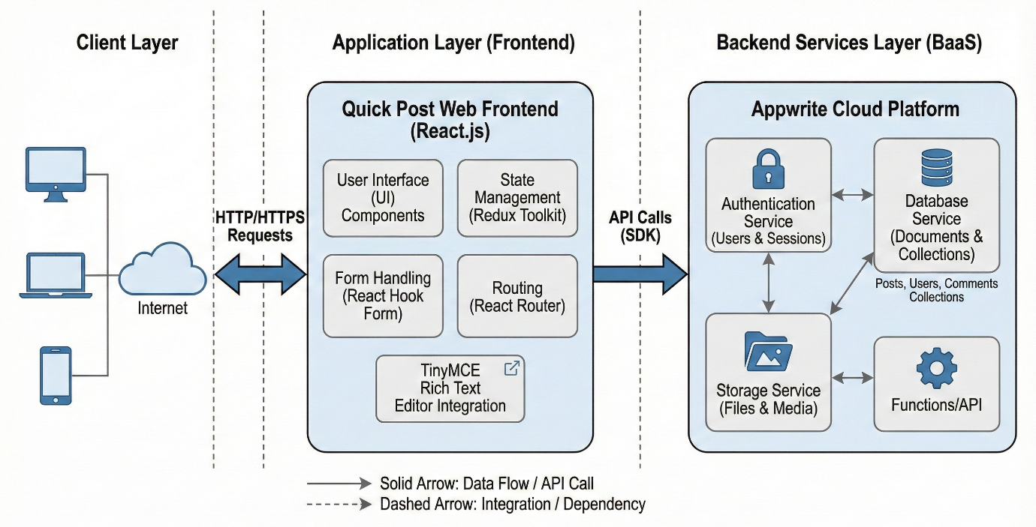

1. **Frontend Architecture**

The frontend is structured around **Components**, the building blocks of React.

* **Container/Layout Components:** Define the skeleton of the page (Header, Footer, Sidebar). These components maintain the visual structure across different routes.
* **Page Components:** Represent specific routes (Home, Login, AddPost). These act as the "smart" components that fetch data and pass it down to children.
* **UI Components:** Reusable widgets (Button, Input, PostCard). These are "dumb" or "presentational" components that simply render data passed to them via props.

The data flow is managed via **Redux**. When a user logs in, the user object is stored in the Redux Store. Components subscribe to this store; if the user logs out, the store updates, and all components reactively update (e.g., the "Login" button changes to "Logout"). This ensures the UI is always in sync with the application state.

1. **Backend Services (Appwrite)**

Appwrite acts as the backend engine. It abstracts the complexity of managing a server, Docker containers, and database connections.

* **Authentication Service:** Manages sessions, JWT tokens, and user encryption. It handles complex security flows like password hashing (Argon2) and rate limiting.
* **Database Service:** Stores metadata about posts (Title, Content, Author ID, Slug). It allows for structured queries (e.g., "Get all posts where status is active").
* **Storage Service:** Stores the physical image files associated with blog posts. It provides capabilities for image transformation (resizing, cropping) on the fly.

**Database Design**

Since Appwrite is a NoSQL-based system (similar to MongoDB), data is stored in **Collections** and **Documents** rather than Tables and Rows. However, for the purpose of this report, we define the schema structurally.

Table 4.1 Database Schema – 'Users' Collection

Note: Managed internally by Appwrite Auth Service

|  |  |  |
| --- | --- | --- |
| **Field** | **Type** | **Description** |
| $id | String | Unique User ID (Primary Key) |
| name | String | User's full name |
| email | String | User's email address (Unique) |
| password | Hash | Encrypted password string |
| prefs | JSON | User preferences (optional) |

Table 4.2: Database Schema – 'Posts' Collection

|  |  |  |  |
| --- | --- | --- | --- |
| **Field Name** | **Type** | **Required** | **Description** |
| $id | String | Yes | Unique ID (Primary Key) |
| title | String | Yes | Title of the blog post |
| content | String | Yes | HTML content generated by TinyMCE |
| featuredImage | String | Yes | File ID linking to Storage Bucket |
| status | Enum | Yes | 'active' or 'inactive' |
| userId | String | Yes | Foreign Key linking to User ID |
| $createdAt | DateTime | Yes | Auto-generated timestamp |

1. **ER Diagram and Data Flow Diagram**

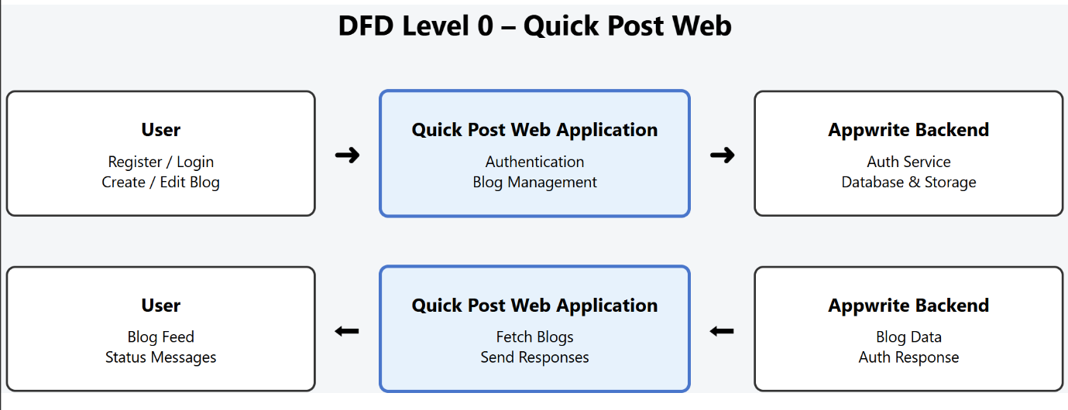Figure 4.2 Data Flow Diagram (DFD) Level 0

Figure 4.3 Data Flow Diagram (DFD) Level 1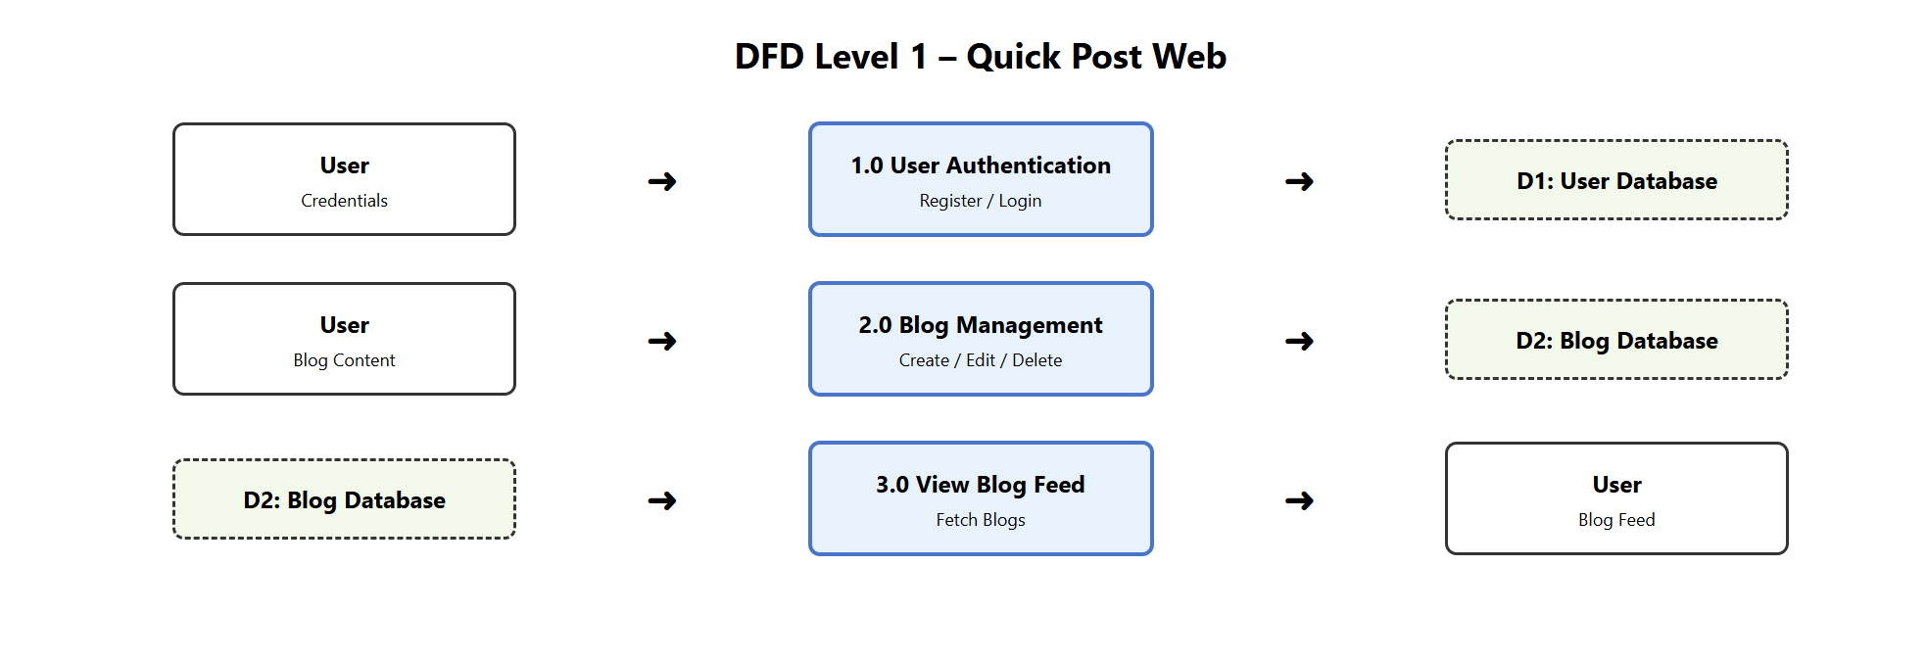

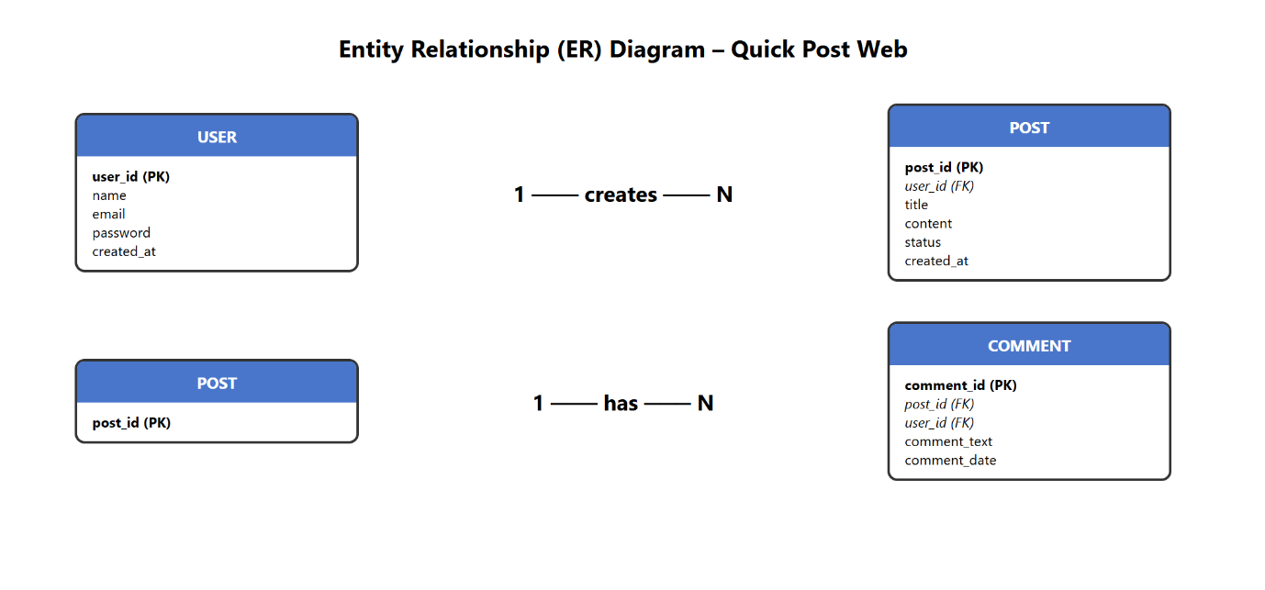Figure 4.4 Entity Relationship (ER) Diagram

**CHAPTER 5: TECHNOLOGIES & TOOLS USED**

1. **React.js**

React.js forms the foundation of the frontend architecture of Quick Post Web. Developed and maintained by Meta (Facebook), React enables the creation of dynamic and responsive user interfaces using a component-based architecture. Each component represents an independent and reusable unit of the UI, improving code organization and maintainability.

A key feature of React is the **Virtual DOM**, which acts as an in-memory representation of the real DOM. When application state changes, React performs a **diffing** process to identify minimal changes and updates only the affected components through **reconciliation**. This approach significantly improves performance compared to traditional web applications that re-render entire pages.

Quick Post Web extensively uses **React Hooks**, introduced in React 16.8, to manage component behavior efficiently. The useState hook manages local state such as UI visibility, useEffect handles side effects like API calls and lifecycle events, and useCallback optimizes performance by preventing unnecessary re-rendering of child components.

1. **Redux Toolkit (State Management)**

While React efficiently manages local component state, sharing data across multiple and deeply nested components can lead to issues such as **prop drilling**, which reduces code readability and scalability. Redux Toolkit (RTK) addresses this problem by providing a centralized **global store** to manage application-wide state.

RTK simplifies traditional Redux by reducing boilerplate code and offering utilities such as createSlice, which automatically generates action creators and reducers. In Quick Post Web, Redux Toolkit is used to manage critical global data such as user authentication status and shared application state. Additionally, RTK improves performance through optimized selectors and offers advanced debugging capabilities using Redux DevTools.

Table 5.1: Technical Comparison of State Management Libraries

|  |  |  |
| --- | --- | --- |
| **Feature** | **Context API (Built-in)** | **Redux Toolkit (External)** |
| **Complexity** | Low | Moderate |
| **Boilerplate** | Minimal | Reduced (compared to vanilla Redux) |
| **Performance** | Can cause unnecessary re-renders | Optimized (Selectors) |
| **Debugging** | Basic | Advanced (Redux DevTools) |
| **Use Case in Project** | Theme toggling (if used) | User Authentication & Global Data |

1. **React Hook Form (Form Handling)**

Form handling in React applications can become complex and verbose. React Hook Form was chosen in Quick Post Web due to its high performance and clean developer experience. It utilizes **uncontrolled components** and references (ref) to manage form data, minimizing re-renders during user input.

The library also provides robust validation mechanisms. In Quick Post Web, React Hook Form ensures that essential fields such as blog title and content are validated before submission, improving data integrity and user experience.

1. **TinyMCE (Rich Text Editor)**

To support rich and formatted blog content, TinyMCE was integrated as the rich text editor. Unlike standard HTML <textarea> elements, TinyMCE provides a word-processor-like interface, allowing users to apply formatting such as headings, links, lists, and images.

TinyMCE outputs standardized HTML content, which is sanitized before being stored in the Appwrite database to ensure security. A custom wrapper component (<RTE />) was implemented to integrate TinyMCE with React Hook Form using the Controller component, enabling seamless form state synchronization.

1. **Appwrite (Backend as a Service)**

Appwrite serves as the backend infrastructure for Quick Post Web and was selected to demonstrate modern cloud-native development practices. As an open-source Backend-as-a-Service (BaaS) platform, Appwrite provides essential backend features without manual server management.

It offers structured databases for storing blog content, secure storage services for image uploads, and an Account API for user authentication and session management. Appwrite handles encryption, secure token storage, and access control through permissions, significantly reducing security risks and backend complexity.

1. **HTML5, CSS3, and Tailwind CSS**

HTML5 was used to define the structural foundation of the Quick Post Web application by providing a clean, semantic, and standardized markup. Semantic elements such as <header>, <nav>, <section>, <article>, and <footer> were employed to clearly represent the logical structure of the application. This semantic approach enhances accessibility for assistive technologies, improves search engine optimization (SEO), and ensures better readability and maintainability of the codebase.

CSS3 was utilized to manage layout styling, responsiveness, and visual enhancements. Modern CSS features such as Flexbox and Grid were applied to create responsive layouts that adapt seamlessly across different screen sizes and devices. CSS3 animations and transitions were selectively used to improve user experience by providing smooth visual feedback during user interactions.

To further streamline the styling process, **Tailwind CSS**, a utility-first CSS framework, was integrated into the project. Tailwind CSS enables rapid user interface development by allowing predefined utility classes to be applied directly within JSX components. This eliminates the dependency on large, custom CSS files and significantly reduces styling complexity. The use of utility classes promotes consistency in design, enforces a standardized design system, and improves scalability as the application grows. Overall, the combined use of HTML5, CSS3, and Tailwind CSS resulted in a responsive, maintainable, and visually consistent user interface.

1. **Version Control (Git)**

Git was employed as the version control system throughout the development lifecycle of the Quick Post Web application. It played a crucial role in managing source code changes, maintaining development history, and ensuring code stability. Each significant feature, enhancement, or bug fix was committed with descriptive and meaningful commit messages, enabling efficient tracking of project progress and easy rollback when required.

The project repository was hosted on **GitHub**, which provided a secure and centralized platform for source code storage and backup. GitHub also facilitated professional development workflows, including repository management, commit history visualization, and branch control. A **feature-branching strategy** was adopted, where individual features were developed and tested in separate branches before being merged into the main branch. This approach minimized conflicts, improved code quality, and closely aligned with industry-standard software development practices.

By using Git and GitHub, the project maintained high code integrity, improved collaboration readiness, and followed best practices commonly used in real-world software development environments.

**CHAPTER 6: FUNCTIONAL MODULES OF QUICK POST WEB**

1. **User Authentication & Authorization**

User authentication and authorization function as the security gatekeeper of the Quick Post Web application. This module ensures that only registered and authenticated users are permitted to create or modify blog content, while general users are allowed to read published posts without logging in. During the sign-up process, the user provides their name, email address, and password. These details are sent to Appwrite using the account.create() API. Once the account is successfully created, the system automatically logs the user in, providing a seamless onboarding experience.

For existing users, the login process is handled using Appwrite’s account.create EmailSession() API. Upon successful authentication, the user information is stored in the Redux global state through the authSlice, enabling consistent access to authentication data across the application. To prevent unauthorized access to restricted pages, a protected routing mechanism is implemented using a custom layout component named AuthLayout. This component continuously checks the authentication status from the Redux store. If an unauthenticated user attempts to access protected routes such as /add-post, the useEffect hook detects the invalid state and redirects the user to the Login page using React Router’s useNavigate() function.

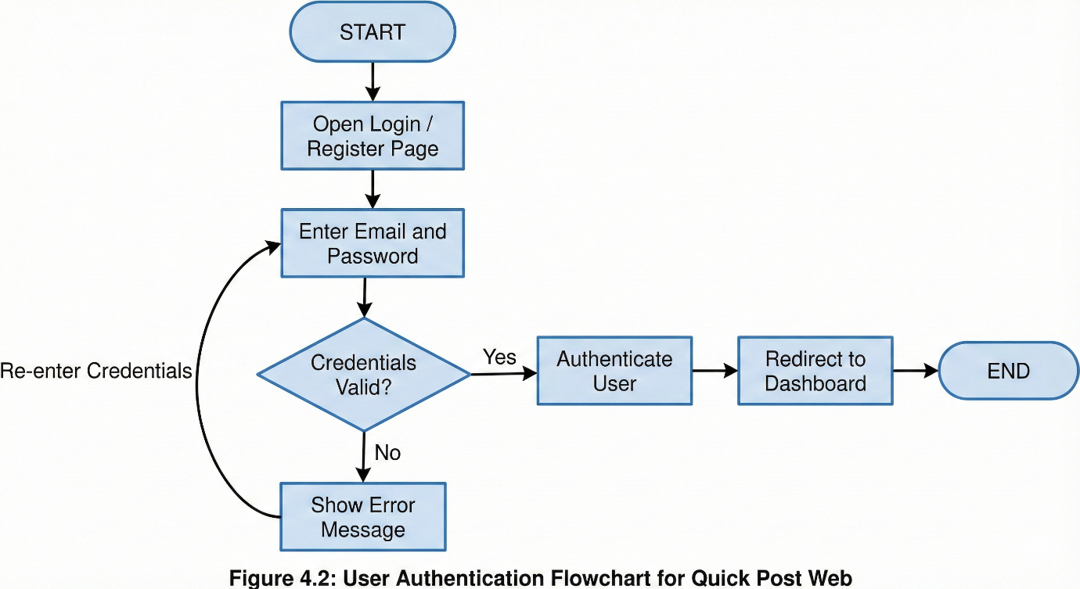Figure 6.1 Flowchart of User Authentication Process

1. **Post Creation and Editing**

Post creation and editing constitute the core operational functionality of the Quick Post Web application, enabling users to generate, modify, and manage blog content in a structured and efficient manner. This module is accessible only to authenticated users, ensuring accountability and content integrity across the platform. When creating a new post, the user is required to provide a title, which serves as the primary identifier of the blog entry. To enhance readability and search engine optimization, the application automatically converts the title into a URL-friendly slug by removing special characters, converting text to lowercase, and replacing spaces with hyphens. This slug is used as a unique identifier within application routes, enabling clean and meaningful URLs.

The main body of the post is authored using the TinyMCE rich text editor, which provides advanced content formatting capabilities such as headings, lists, hyperlinks, and embedded media. This allows users to create well-structured and visually appealing blog posts without requiring direct knowledge of HTML or CSS. Additionally, each post is assigned a status value, typically marked as active or inactive. This status mechanism allows users to control the visibility of their content, making it possible to save drafts or temporarily hide posts without deleting them from the system.

Image handling within the post creation process is designed with performance and scalability in mind. When a user selects an image, the application uploads the file directly to Appwrite Storage instead of storing it within the database. Upon successful upload, Appwrite generates a unique file identifier, which is then stored as a reference in the corresponding post document. By separating media storage from textual data, the application avoids unnecessary database load, reduces storage overhead, and improves overall system responsiveness, particularly as the number of posts and media files increases.

The post editing functionality is designed to provide a seamless and efficient user experience. When a user chooses to edit an existing post, the application retrieves the associated post data using the getPost() API and automatically populates the form fields with the existing values. This allows users to modify specific elements of the post without re-entering all information. During editing, users have the option to retain the previously uploaded image or replace it with a new one. If a new image is uploaded, the application ensures that the old image file is deleted from Appwrite Storage. This cleanup process prevents unused files from accumulating, optimizes storage utilization, and ensures efficient resource management within the system.

1. **Blog Listing and Viewing**

The blog listing and viewing module is responsible for presenting published content to users in a structured, efficient, and user-friendly manner. It acts as the primary interface through which readers interact with the application’s content. The Home page serves as the central content hub and dynamically retrieves all blog posts from the Appwrite Posts collection that are marked with an active status. This filtering mechanism ensures that only approved and publicly visible posts are displayed, thereby maintaining content relevance and quality. The retrieval process is handled through the appwriteService.getPosts() method, which abstracts backend communication and simplifies data access for the frontend.

Once the data is retrieved, each post is dynamically rendered as an individual PostCard component. These components provide a concise summary of each blog post, typically including elements such as the title, featured image, and a brief description. This component-based rendering approach enhances modularity and reusability while ensuring consistent visual presentation across the application. By loading posts dynamically, the system supports scalability and can efficiently handle an increasing number of blog entries without affecting performance.

When a user selects a specific blog post, they are redirected to a dedicated route uniquely identified by the post’s slug. The slug-based routing mechanism improves both readability and search engine optimization by creating meaningful and human-readable URLs. On the Post page, the application fetches the corresponding document from the database and renders the complete blog content. Since the content is stored in HTML format generated by the TinyMCE rich text editor, it must be handled carefully during rendering. The application uses the html-react-parser library to safely parse and display the HTML content within React components. This ensures that complex formatting such as headings, lists, images, and links is preserved while preventing rendering issues or security vulnerabilities. As a result, users experience rich, well-formatted blog content in a secure and controlled manner.

1. **State Management**

State management in Quick Post Web is implemented using Redux Toolkit to ensure consistency, predictability, and scalability across the application. Redux serves as a centralized store that maintains the global state, enabling different components to access and respond to shared data without unnecessary coupling. The Redux store is configured in the store.js file, which integrates all application slices into a unified state container. Authentication-related logic is managed separately within the authSlice.js file, following the principle of separation of concerns.

Initially, the authentication state indicates that no user is logged in, with the status set to false and user data set to null. When a user successfully logs in, the authentication state is updated to reflect an active session, and the corresponding user information is stored in the global state. This allows the application to retain authentication details across page reloads and component transitions. When the user logs out, the state is reset, ensuring that all sensitive user data is removed and access permissions are revoked.

This centralized state management approach enables consistent application behavior across different modules. User interface elements such as the header dynamically adjust based on the authentication state, displaying appropriate options such as login, logout, or post creation buttons. Similarly, protected routes rely on the same global state to determine whether a user is authorized to access restricted pages. By eliminating redundant API calls and avoiding complex data passing between components, Redux improves maintainability, performance, and overall system reliability.

1. **Responsive UI Design**

The user interface of Quick Post Web is developed using a mobile-first design philosophy to ensure optimal usability across devices of varying screen sizes. This approach prioritizes small-screen design during development and progressively enhances the layout for larger screens. As a result, the application delivers a consistent and accessible user experience on smartphones, tablets, and desktop systems.

The blog listing layout is implemented using a responsive grid system powered by Tailwind CSS utility classes. On mobile devices, blog posts are displayed in a single-column layout, allowing users to focus on content without visual clutter. As the screen size increases, the grid automatically adjusts to display multiple columns on tablets and desktops, effectively utilizing available screen space and improving content discoverability. This adaptive layout ensures that the interface remains visually balanced and easy to navigate across different resolutions.

The navigation header is also designed to respond dynamically to screen size changes. On smaller devices, navigation elements are compactly arranged or simplified to maintain clarity and ease of use. On larger screens, the navigation expands to provide direct access to additional features without compromising visual hierarchy. This responsive design strategy enhances usability, accessibility, and aesthetic consistency, ensuring that Quick Post Web offers a smooth and intuitive user experience regardless of the device being used.

|  |  |  |  |
| --- | --- | --- | --- |
| **Req ID** | **Requirement Summary** | **Test Case Mappings** | **Status** |
| **FR_01** | User Registration (Valid & Invalid scenarios) | TC_01_01, TC_01_02, TC_01_03 | Passed |
| **FR_02** | User Login Authentication | TC_02_01, TC_02_02, TC_02_03 | Passed |
| **FR_03** | Blog Post Creation (Content & Media) | TC_03_01, TC_03_02, TC_03_03 | Passed |
| **FR_04** | Post Editing (Author only permission) | TC_04_01, TC_04_02 | Passed |
| **FR_05** | Post Deletion (Author only permission) | TC_05_01, TC_05_02 | Passed |
| **FR_06** | Post Viewing (All Posts list & Single Post view) | TC_06_01, TC_06_02 | Passed |
| **FR_07** | Rich Text Editor Functionality (TinyMCE) | TC_07_01, TC_07_02 | Passed |
| **FR_08** | User Logout & Session Termination | TC_08_01 | Passed |

Table 6.1: Functional Requirements Traceability Matrix (Condensed)

**CHAPTER 7: IMPLEMENTATION DETAILS**

1. **Folder Structure**

A **scalable and modular folder structure** was adopted in the *Quick Post (PostApp)* project to ensure code readability, maintainability, and ease of future enhancements. The structure follows **separation of concerns**, clearly dividing configuration files, UI components, pages, services, and state management logic.

PostApp/

├── .env

├── .gitignore

├── eslint.config.js

├── index.html

├── Logo/

│ ├── About.webp

│ ├── apple-touch-icon.png

│ ├── favicon.ico

│ ├── favicon.svg

│ ├── HeroMain.webp

│ ├── Login.png

│ ├── logo-192x192.png

│ ├── logo-512x512.png

│ ├── logo-96x96.png

│ ├── main.png

│ ├── manifest.json

│ └── Signup.png

├── node_modules/

├── package.json

├── package-lock.json

├── README.md

├── src/

│ ├── App.jsx

│ ├── Appwrite/

│ │ ├── auth.js

│ │ ├── databases.js

│ │ └── Test.js

│ ├── Component/

│ │ ├── About.jsx

│ │ ├── ActionButton.jsx

│ │ ├── AIAssistant.jsx

│ │ ├── Card.jsx

│ │ ├── CardSkeleton.jsx

│ │ ├── ChangePassword.jsx

│ │ ├── Contact.jsx

│ │ ├── DashboardOverview.jsx

│ │ ├── EmailVerification.jsx

│ │ ├── Error.jsx

│ │ ├── ErrorMessage.jsx

│ │ ├── Features.jsx

│ │ ├── Footer.jsx

│ │ ├── Header.jsx

│ │ ├── Hero.jsx

│ │ ├── KpiCard.jsx

│ │ ├── Loader.jsx

│ │ ├── Logout.jsx

│ │ ├── Myprofile.jsx

│ │ ├── Oauth.jsx

│ │ ├── PagesLink.jsx

│ │ ├── PopupMessage.jsx

│ │ ├── ProfileSkeleton.jsx

│ │ └── Services.jsx

│ ├── Configenv/

│ │ └── env.js

│ ├── Editor/

│ │ └── BundledEditor.jsx

│ ├── Feature/

│ │ ├── Auth.js

│ │ ├── Post.js

│ │ ├── Profile.js

│ │ └── ThemeMode.js

│ ├── Pages/

│ │ ├── Dashboard.jsx

│ │ ├── Edit.jsx

│ │ ├── EmailVerificationConfirm.jsx

│ │ ├── ForgotPassword.jsx

│ │ ├── Home.jsx

│ │ ├── Login.jsx

│ │ ├── NewPassword.jsx

│ │ ├── Post.jsx

│ │ ├── PostView.jsx

│ │ ├── Profile.jsx

│ │ ├── Signup.jsx

│ │ └── Test.jsx

│ ├── Store/

│ │ └── Store.js

│ ├── index.css

│ └── main.jsx

└── vite.config.js

**Folder Structure Explanation:**

* **src/Component**: Contains reusable UI components (presentational components).
* **src/Pages**: Contains page-level components mapped to application routes.
* **src/Appwrite**: Handles all backend interactions (authentication and database services).
* **src/Feature**: Redux Toolkit slices for authentication, posts, profile, and theme management.
* **src/Store**: Central Redux store configuration.
* **Configenv**: Centralized environment configuration.
* **Editor**: Custom TinyMCE rich-text editor integration.
* **Logo**: Static assets such as icons and images.

This organization supports **scalability**, **team collaboration**, and **clean architecture**.

Figure 7.1 React Component Hierarchy Tree

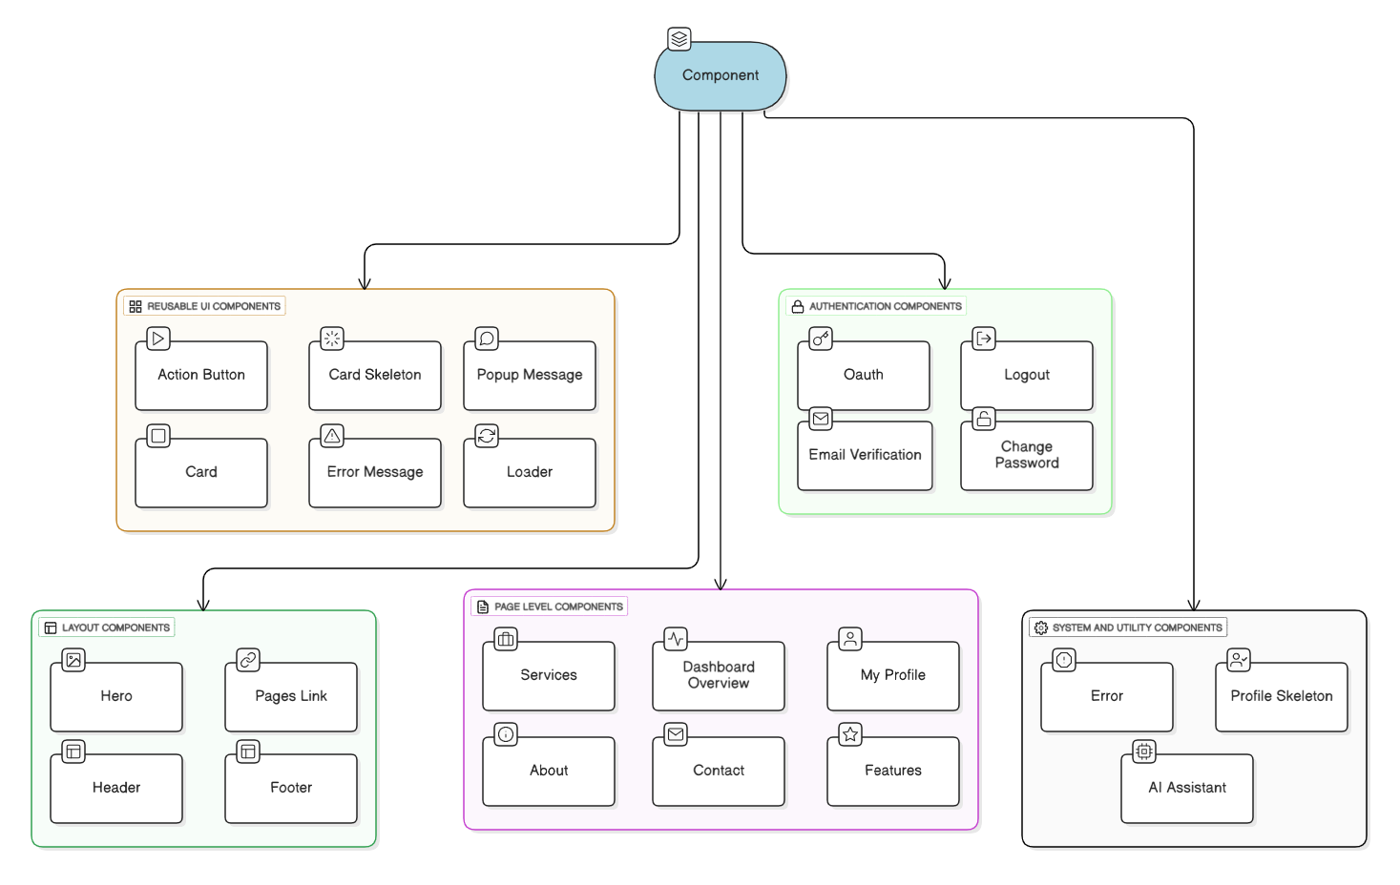

1. **Component-Based Design**

The application follows a **Component-Based Architecture**, implicitly using the **Container/Presentational Pattern**.

* **Presentational Components** focus only on UI rendering.
* **Container Components** handle data fetching, state management, and logic.

**Example: Select.jsx Component**

* Uses React.forwardRef to allow parent components to access the internal <select> element.
* Accepts an options array as a prop and dynamically renders <option> elements.
* Can be reused across multiple forms without coupling it to specific data logic.

**Advantages:**

* High reusability
* Clean separation of logic and UI
* Improved testability and maintainability

1. **API Integration Logic**

To avoid tightly coupling UI components with backend logic, a **Service Class Pattern** was implemented.

**Authentication Service (auth.js)**

* A class named AuthService encapsulates all authentication-related logic.
* Methods include:
  + login()
  + logout()
  + signup()
  + getCurrentUser()

**Singleton Pattern Implementation**

const authService = new AuthService();

export default authService;

* A single instance of the service is shared across the application.
* Components simply import and use the service:

authService.login(email, password);

**Benefits**

* Backend abstraction
* Easy migration from Appwrite to Firebase or another provider
* Cleaner and more readable components
* Centralized error handling

1. **Database Collections and Queries**

The application interacts with the backend using **Appwrite Databases API**.

* Data retrieval is optimized using **server-side queries**.
* Example:

Query.equal('status', 'active')

This ensures that:

* Only active posts are fetched
* Unnecessary data transfer is avoided
* Performance is improved compared to client-side filtering

**Collections Used:**

* Posts Collection
* Users Profile Collection
* Contacts Collection

1. **Code Snippets with Explanation**

**Snippet 1: Environment Variable Configuration**

**File:** Configenv/env.js

const conf = {

appwriteUrl: String(import.meta.env.VITE_APPWRITE_URL),

appwriteProjectId: String(import.meta.env.VITE_APPWRITE_PROJECT_ID),

appwriteDatabaseId: String(import.meta.env.VITE_APPWRITE_DB_ID),

appwriteCollectionId: String(import.meta.env.VITE_APPWRITE_COLLECTION_ID),

appwriteContactCollectionId: String(import.meta.env.VITE_APPWRITE_COLLECTION_CONTECT_ID),

appwriteProfileCollectionId: String(import.meta.env.VITE_APPWRITE_COLLECTION_PROFILE_ID),

appwriteBucketId: String(import.meta.env.VITE_APPWRITE_BUKET_ID),

redirectSuccess: String(import.meta.env.VITE_REDIRECT_SUCCESS),

redirectFailure: String(import.meta.env.VITE_REDIRECT_FAILURE),

redirectPassword: String(import.meta.env.VITE_REDIRECT_PASSWORD),

redirectEmail: String(import.meta.env.VITE_REDIRECT_EMAIL)

};

export default conf;

**Explanation**

* All environment variables are explicitly converted to **String** to prevent runtime type errors.
* Configuration is centralized in one file, improving maintainability.
* Makes deployment easier across **development**, **testing**, and **production** environments.
* Sensitive information is kept outside source code using .env files.

1. **Environment Variable Setup (.env)**

# Appwrite Configuration

VITE_APPWRITE_URL="https://cloud.appwrite.io/v1"

VITE_APPWRITE_PROJECT_ID="your_appwrite_project_id"

VITE_APPWRITE_DB_ID="your_appwrite_database_id"

VITE_APPWRITE_COLLECTION_ID="your_posts_collection_id"

VITE_APPWRITE_COLLECTION_CONTECT_ID="your_contacts_collection_id"

VITE_APPWRITE_COLLECTION_PROFILE_ID="your_profiles_collection_id"

VITE_APPWRITE_BUKET_ID="your_bucket_id"

# Redirect URLs

VITE_REDIRECT_SUCCESS="http://localhost:5173/dashboard"

VITE_REDIRECT_FAILURE="http://localhost:5173/login"

VITE_REDIRECT_PASSWORD="http://localhost:5173/reset-password"

VITE_REDIRECT_EMAIL="http://localhost:5173/verify-email"

**Key Benefits:**

* Improves security by hiding credentials
* Allows easy configuration without code changes
* Supports multiple deployment environments

**CHAPTER 8: USER INTERFACE & USER EXPERIENCE**

1. **Design Principles Used**

The user interface of the *Quick Post* web application was designed based on the core philosophy of **“Minimalism and Readability.”** The primary goal was to provide a clean, distraction-free writing and reading experience while maintaining visual appeal and usability.

* **Whitespace Usage:**  
  Adequate whitespace was intentionally incorporated between blog cards, text blocks, and form elements. This reduces cognitive load on users and prevents visual clutter, allowing content to remain the focal point. The principle of *“less is more”* helps users quickly scan and consume information.
* **Typography Hierarchy:**  
  A consistent sans-serif font family was selected for the entire application to ensure modern aesthetics and legibility. Clear font hierarchy was established:
  + Headings use larger font sizes and increased font weight.
  + Body text uses moderate line spacing for comfortable reading.  
    This distinction helps users easily differentiate between titles, summaries, and detailed content.
* **User Feedback and Responsiveness:**  
  Visual feedback mechanisms were integrated to enhance user interaction and system transparency. Examples include:
  + Button hover effects and color transitions
  + Loaders and skeleton screens during API calls
  + Error and success messages for form submissions  
    These feedback cues improve user confidence and perceived performance of the application.

1. **Layout and Navigation**

The layout follows a **responsive, content-first approach**, ensuring usability across desktops, tablets, and mobile devices.

* **Header Design:**  
  The header contains the application logo and navigation links. Navigation items are rendered conditionally based on authentication state:
  + **Guest User:** Home, Login, Signup
  + **Authenticated User:** Home, Add Post, Logout  
    This conditional navigation simplifies the interface and prevents unauthorized access to restricted features.
* **Card-Based Layout:**  
  The blog feed uses a **CSS Grid/Flexbox-based card layout** for consistency and responsiveness. Each card maintains a uniform height and structure:
  + Top section displays the featured image
  + Bottom section contains the post title and a short excerpt  
    This design ensures visual balance and improves content discoverability.
* **Responsive Behavior:**  
  The grid layout automatically adjusts the number of columns based on screen size, ensuring an optimal viewing experience on all devices.

1. **Accessibility Considerations**

Accessibility was treated as a fundamental requirement rather than an afterthought.

* **Form Accessibility:**  
  All form fields are associated with proper <label> elements or aria-label attributes, enabling screen readers to interpret input fields correctly.
* **Color Contrast:**  
  High-contrast color combinations (dark text on light background) were used to enhance readability and comply with **WCAG 2.1 AA accessibility standards**.
* **Keyboard Navigation:**  
  The application supports full keyboard navigation using the **Tab** key. Since native HTML elements are used extensively in React components, focus management and keyboard accessibility are preserved without additional complexity.

These considerations make the application usable for users with visual or motor impairments.

1. **Screenshots Explanation**

The screenshots included in this report demonstrate the practical implementation of the above design principles:

* **UI Screenshot – Welcome Page:** Clean landing page with hero section and Login/Signup call-to-action buttons.
* **UI Screenshot – User Login Interface:** Centered login form with email and password fields for focused authentication.
* **UI Screenshot – Home Feed and Dashboard:** Grid-based post cards with images and titles for easy content browsing.
* **UI Screenshot – Rich Text Editor Interface:** TinyMCE editor with formatting tools and live content preview.
* **UI Screenshot – Mobile Responsiveness:** Responsive layout adapting smoothly to mobile screen sizes.

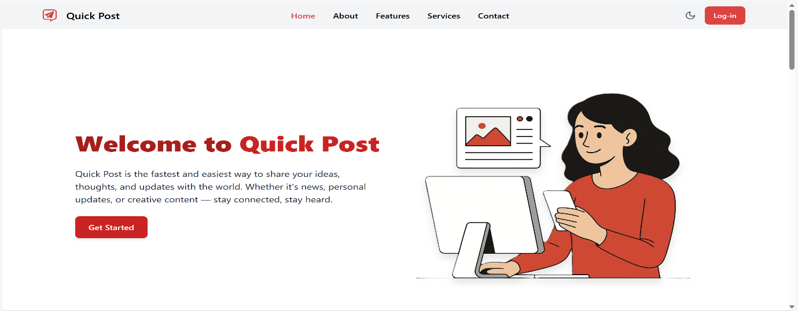Figure 8.1 UI Screenshot – Welcome Page

Figure 8.2 UI Screenshot – User Login Interface

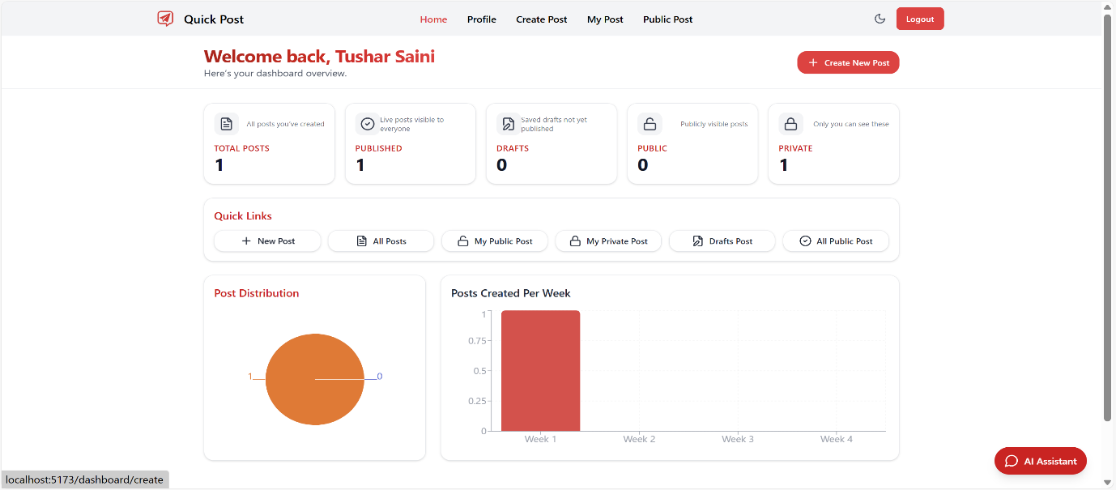Figure 8.3 UI Screenshot – Home Feed and Dashboard

Figure 8.4 UI Screenshot – Rich Text Editor Interface

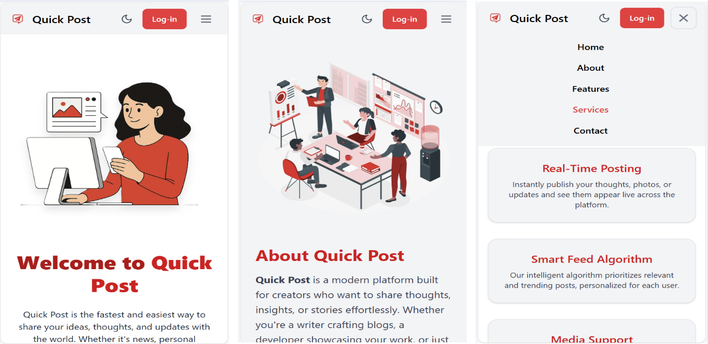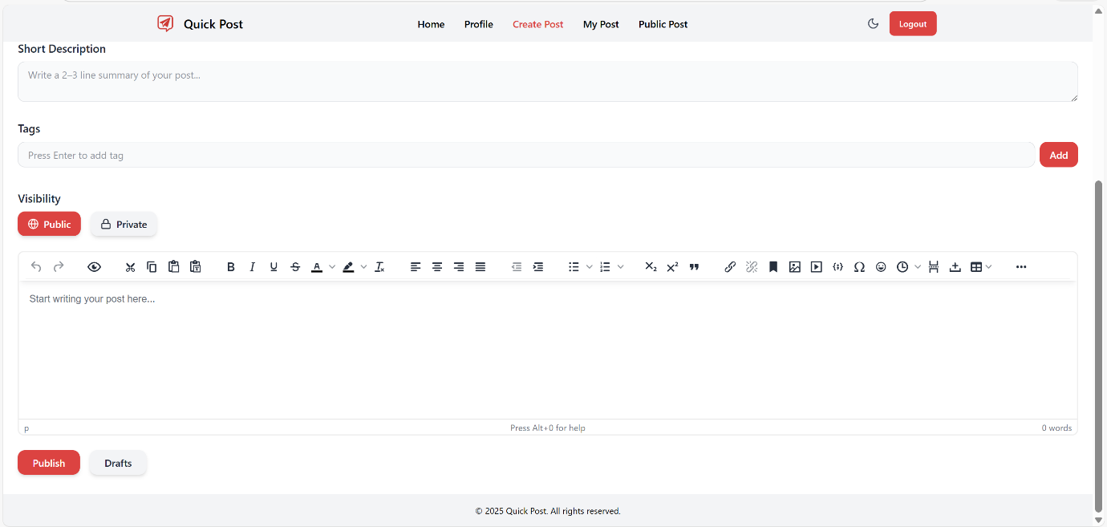Figure 8.5 UI Screenshot – Mobile Responsiveness

**CHAPTER 9: TESTING & VALIDATION**

1. **Functional Testing**

Testing was conducted primarily via **Manual Black Box Testing**. This involves testing the application's functionality from the user's perspective without looking at the internal code structure.

Table 9.1 User Authentication Test Cases

|  |  |  |  |  |  |
| --- | --- | --- | --- | --- | --- |
| **Test Case ID** | **Test Scenario** | **Test Data** | **Expected Result** | **Actual Result** | **Status** |
| TC_01 | Valid Signup | New Email, Valid Pass | User created, Auto-login | User created | Pass |
| TC_02 | Invalid Login | Wrong Password | Error Message Displayed | Alert: "Login Failed" | Pass |
| TC_03 | Logout | Click Logout Btn | Session end, Redirect to Home | Redirected | Pass |

Table 9.2 Post Management Test Cases

|  |  |  |  |  |  |  |
| --- | --- | --- | --- | --- | --- | --- |
| **Test Case ID** | **Test Scenario** | **Test Data** |  | **Expected Result** | **Actual Result** | **Status** |
| TC_04 | Create Post | Title, Content, Img |  | Post saved to DB, listed on Home | Saved & Listed | Pass |
| TC_05 | Edit Post | Change Title |  | Title updates in DB | Updated | Pass |
| TC_06 | Delete Post | Click Delete |  | Post removed from DB & Storage | Removed | Pass |

1. **User Input Validation**

Validation was implemented at two levels:

1. **Frontend (React Hook Form):** Prevents the submission of empty forms. It checks if the email is in a valid format (regex pattern).
2. **Backend (Appwrite):** Rejects requests if required fields are missing or if data types don't match (e.g., trying to save text in a date field).
3. **Performance Testing**

* **Loading Speed:** The application loads effectively instantly after the initial bundle download due to React's client-side routing.
* **Network Optimization:** API calls were optimized to fetch only necessary data. Image previews use the Appwrite getPreview endpoint which delivers smaller, optimized images for the card view, saving bandwidth.

1. **Error Handling**

* **Try-Catch Blocks:** All async API calls are wrapped in try-catch blocks.

**User Feedback:** If an error occurs (e.g., network failure), the user is not left in the dark. Although currently implemented as console logs or basic alerts, the architecture supports integrating a Toast notification system.

Table 9.3 Cross-Browser Compatibility Testing Results

|  |  |  |  |  |  |  |
| --- | --- | --- | --- | --- | --- | --- |
| **Browser** | **Version** | **Operating System** | **Layout Rendering** | **Functional Integrity (Auth/Post)** | **Rich Text Editor (TinyMCE)** | **Status** |
| **Google Chrome** | 120.0+ | Windows 11 / macOS | Perfect | Pass | Fully Functional | **Pass** |
| **Mozilla Firefox** | 115.0+ | Windows 10 / Linux | Perfect | Pass | Fully Functional | **Pass** |
| **Microsoft Edge** | 120.0+ | Windows 11 | Perfect | Pass | Fully Functional | **Pass** |
| **Safari** | 17.0+ | macOS Sonoma | Minor padding diff | Pass | Fully Functional | **Pass** |
| **Safari (Mobile)** | iOS 17 | iPhone 14 | Responsive Stack | Pass | Toolbar scales (Scrollable) | **Pass** |
| **Opera** | 106.0+ | Windows 10 | Perfect | Pass | Fully Functional | **Pass** |

**CHAPTER 10: CHALLENGES FACED & SOLUTIONS**

1. **Technical Challenges**
2. **Rich Text Editor Integration:**

* *Challenge:* Connecting TinyMCE (which manages its own state) with React Hook Form (which manages form state). The two libraries fight for control of the input value.
* *Solution:* We used the Controller component from React Hook Form. This acts as a mediator, subscribing to the TinyMCE onEditorChange event and passing the new value to the form's onChange handler.

1. **Environment Variable Issues:**

* *Challenge:* The application failed to connect to the database after initial setup. The API calls were returning "Unauthorized" or "Invalid Project ID".
* *Solution:* It was discovered that React (via Vite) requires environment variables to be prefixed with VITE_. Additionally, creating a conf.js file to strictly typecast these variables to Strings resolved issues where numbers were being misinterpreted.

1. **State Persistence:**

* *Challenge:* When a user refreshed the page, the Redux store reset to its initial state, logging the user out visually even if the Appwrite session was still active.
* *Solution:* Implemented a useEffect hook in App.jsx that runs on mount. It calls authService.getCurrentUser(). If a user is returned, it dispatches the login action to re-hydrate the Redux store.

1. **Learning Curve**

Transitioning from vanilla JavaScript to React's "Thinking in Components" required a mental shift. Understanding that the UI is a function of State (UI = f(State)) took practice. The asynchronous nature of setState and the Rules of Hooks (e.g., not calling hooks inside loops) were initial hurdles.

1. **Debugging and Optimization**

* **Redux DevTools:** This browser extension was invaluable. It allowed for inspecting every action dispatched and the resulting state change, making it easy to trace logic errors.

**Console Logging:** Strategic placement of logs helped identify the order of execution in asynchronous operations.

**CHAPTER 11: LEARNING OUTCOMES**

By the successful completion of this internship and the associated *Quick Post* project, significant technical, analytical, and professional competencies were achieved. The experience provided strong exposure to modern web development practices and real-world software engineering workflows.

* **React.js Proficiency:** A strong command over React.js was developed, including the use of functional components, React Hooks, and component lifecycle management. The project strengthened the understanding of core React concepts such as the Virtual DOM, diffing, and reconciliation, enabling the development of highly responsive and efficient user interfaces. Component reuse, props management, and conditional rendering were applied extensively throughout the application.
* **State Management Using Redux Toolkit:** The internship provided hands-on experience with Redux Toolkit for managing global application state. Redux slices were implemented to handle authentication, posts, user profiles, and theme preferences. This approach improved data consistency, reduced prop drilling, and enabled predictable state transitions. Such experience is essential for developing large-scale, enterprise-level applications.
* **Backend Integration and API Handling:** Practical knowledge of backend interaction was gained through the implementation of CRUD (Create, Read, Update, Delete) operations. The project utilized Appwrite as a Backend-as-a-Service (BaaS) platform to manage authentication, databases, and file storage. Secure API communication, role-based access, and environment-based configuration enhanced the understanding of scalable backend integration without managing server infrastructure.
* **Debugging and Problem-Solving Skills:** A systematic and confident approach to debugging was developed. Issues were identified and resolved by isolating components, analyzing browser console logs, monitoring network requests, and validating API responses. This structured debugging methodology significantly improved development efficiency and reduced error resolution time.
* **Industry-Oriented Development Practices:** The overall project structure closely mirrors real-world production codebases. Best practices such as modular folder organization, use of environment variables, service abstraction layers, and reusable components were consistently followed. Version control awareness and clean code principles further enhanced professional readiness.
* **Professional Readiness:** Through this internship, the student gained practical exposure to industry-standard tools, workflows, and architectural patterns. The skills acquired enable smooth integration into professional development teams and provide a strong foundation for future roles in frontend and full-stack web development.

**CHAPTER 12: FUTURE ENHANCEMENTS**

The Quick Post Web application has been successfully developed as a fully functional Minimum Viable Product (MVP). While the current system satisfies the core requirements of a modern blogging platform, several enhancements can be incorporated in future versions to improve user engagement, performance, scalability, and overall functionality.

**12.1 Comment System**

A structured comment system can be introduced to enable user interaction on individual blog posts. This enhancement would involve creating a sub-collection or a relational structure in the database where comments are linked to specific posts and users. Features such as threaded replies, comment moderation, and timestamp-based ordering can further enhance community engagement. Implementing this system would also provide practical experience in managing nested relationships within a NoSQL database environment.

**12.2 Like and Reaction Feature**

To increase social interaction, a like or reaction mechanism can be integrated into the platform. Each post document can maintain a counter that increments or decrements based on user actions. Additional constraints such as preventing multiple likes from the same user can be enforced through user-post mapping. This feature would provide insights into content popularity and improve user engagement metrics.

**12.3 Search Engine Optimization (SEO) Enhancements**

Single Page Applications (SPAs) often face limitations in Search Engine Optimization due to client-side rendering. To overcome this challenge, future versions of Quick Post can be migrated to a framework such as Next.js, enabling Server-Side Rendering (SSR) or Static Site Generation (SSG). This enhancement would significantly improve search engine indexing, page load performance, and overall discoverability of blog content.

**12.4 Dark Mode and Theme Customization**

User experience can be further enhanced by implementing a Dark Mode feature using Tailwind CSS’s built-in dark mode utilities. Users would be able to toggle between light and dark themes based on personal preference. The selected theme can be persisted using local storage, ensuring consistency across sessions. This feature also improves accessibility and reduces eye strain during prolonged usage.

**12.5 AI-Powered Features**

The platform can be enhanced with AI-driven functionalities by integrating APIs such as OpenAI. Features like AI-generated summaries, grammar and spell checking, and content suggestions can be embedded directly into the rich text editor. These intelligent features would assist users in producing high-quality content efficiently and add a competitive edge to the platform.

**CHAPTER 13: CONCLUSION**

The development of *Quick Post Web* during this course-based internship has been a highly enriching and transformative learning experience. It effectively bridged the gap between theoretical concepts taught in the university curriculum and the practical, fast-paced requirements of the modern software industry. The project provided valuable exposure to real-world application development, emphasizing both technical competence and professional discipline.

Through the structured learning modules offered via the Udemy platform, the focus shifted beyond basic programming syntax toward understanding software architecture, design patterns, and best development practices. The hands-on implementation of a full-stack web application using React.js, Redux Toolkit, and Appwrite offered deep insights into the complexities involved in modern web development. These included managing global application state, ensuring data consistency, handling secure authentication, and designing intuitive and responsive user interfaces.

The project successfully achieved all its intended objectives. *Quick Post Web* functions as a secure, responsive, and user-friendly blogging platform that supports authentication, content creation, editing, and efficient data management. Performance optimization techniques, modular code organization, and environment-based configuration further enhanced the robustness, maintainability, and scalability of the application.

Beyond technical implementation, the project fostered essential professional skills. It cultivated a structured approach to problem-solving, encouraged consistent documentation reading, and strengthened the ability to debug and analyze complex issues independently. Exposure to industry-aligned project structures and workflows significantly increased confidence in handling real-world engineering challenges.

Additionally, the project reinforced the importance of software quality attributes such as usability, security, and maintainability. Attention to clean user interface design, accessibility considerations, and secure handling of user data highlighted how non-functional requirements play a critical role in the success of modern web applications. These insights have strengthened the understanding of building systems that are not only functional but also reliable and user-centric.

Finally, this internship experience has contributed significantly to professional growth and career readiness. The knowledge gained in frontend technologies, backend integration, and development workflows has built a strong foundation for pursuing advanced roles in Software Engineering and Full-Stack Web Development. The confidence, discipline, and practical exposure acquired through this project will serve as a valuable asset in future academic endeavors and professional opportunities.

**CHAPTER 14: REFERENCES**

1. **Course References**

i. Choudhary, H., *“Mega Project: Build a Modern Web App with React & Appwrite”*, Chai aur Code, Udemy Learning Platform, 2024.

1. **Technical Documentation**

ii. React Official Documentation. Available at: <https://react.dev>

iii. Redux Toolkit Documentation. Available at: <https://redux-toolkit.js.org>

iv. Appwrite Documentation. Available at: <https://appwrite.io/docs>

v. TinyMCE React Integration Guide. Available at: <https://www.tiny.cloud/docs/integrations/react/>

vi. React Hook Form Documentation. Available at: <https://react-hook-form.com>

1. **Standards and Guidelines**

vii. MDN Web Docs. Available at: <https://developer.mozilla.org>